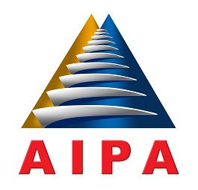
ASEAN INTER-PARLIAMENTARY ASSEMBLY

32nd GENERAL ASSEMBLY
18 – 24 SEPTEMBER 2011, PHNOM PENH, THE CAPITAL CITY
OF THE KINGDOM OF CAMBODIA

Draft.Res.32GA/2011/Soc/0….

Draft Resolution on the Report of the
ASEAN Inter-Parliamentary Assembly
on the Role of Parliamentarians on the Protection
and Promotion of the Rights of Migrant Workers in ASEAN

The Thirty Second General Assembly:

Recalling Resolution No.28GA/2007/Soc/06 on Cooperation on Migration and Protection of the Rights of The Migrant Workers in ASEAN adopted in the 28th AIPA General Assembly held in Kuala Lumpur, which stated to promote comprehensive legislative, administrative and other measures necessary to enhance the protection and promotion of the rights of migrant workers including to promote fair and appropriate employment protection, payments of wages and adequate access to decent working and living condition for Migrant Workers;

Is concerned with the abuse, violence, discrimination as well as violation of human rights of Migrant Workers;

Appreciating the initiative of the National Assembly of the Kingdom of Cambodia to host the Seminar on the Role of Parliamentarians on the Protection and Promotion of the Rights of Migrant Workers, in Phnom Penh, the Capital city of the Kingdom of Cambodia, from 3rd to 6th April 2011 successfully;

Acknowledging the participation and important contribution to the seminar by Parliament Members of the ASEAN Inter-Parliamentary Assembly (AIPA), Special Observer and other International Organizations;

Hereby resolves to:

Adopt the Report and Recommendations of the Seminar on the Role of Parliamentarians
on the Protection and Promotion of the Rights of Migrant Workers on the 23rd of September 2011, during the 32nd General Assembly of AIPA held in Phnom Penh, the Capital City of the Kingdom of Cambodia.

