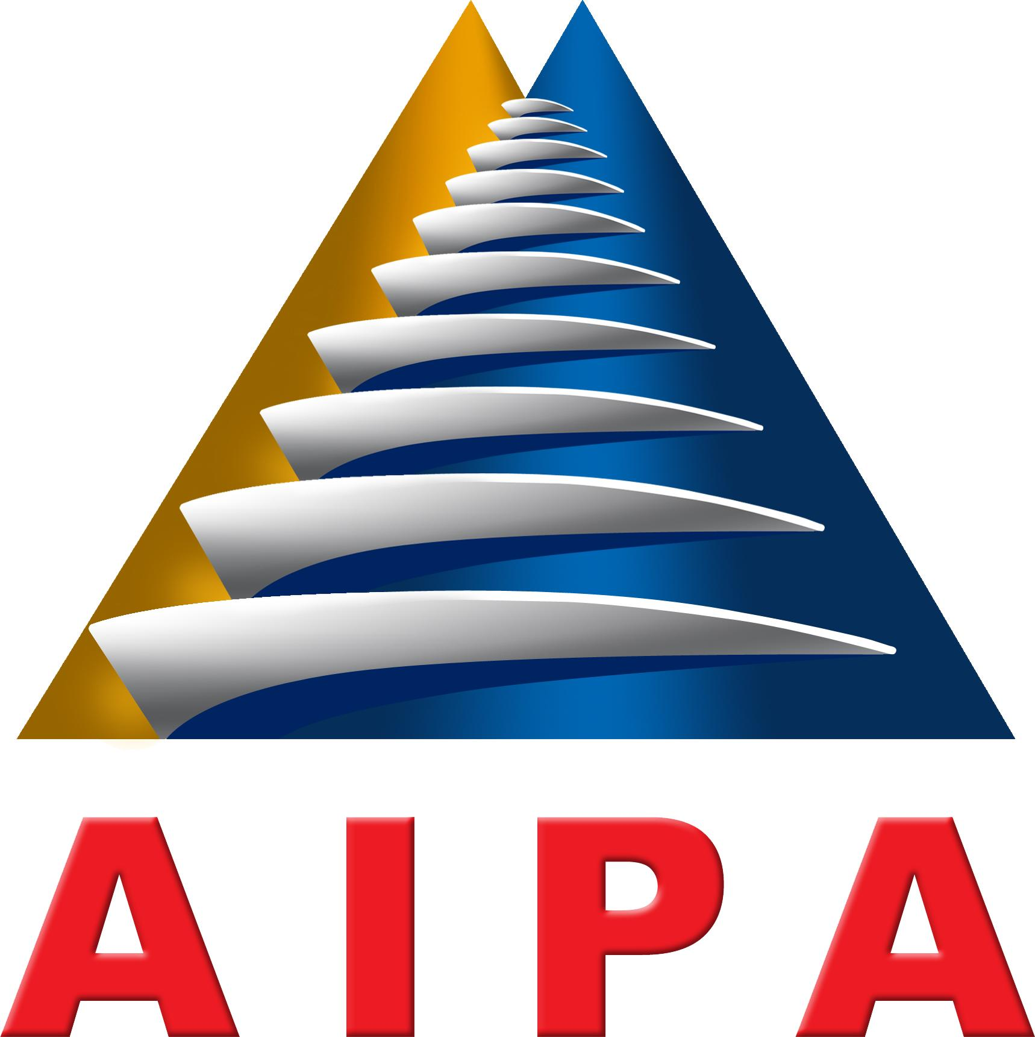

THE 34th GENERAL ASSEMBLY
ASEAN INTER-PARLIAMENTARY ASSEMBLY
BANDAR SERI BEGAWAN, BRUNEI DARUSSALAM
17th – 23th SEPTEMBER 2013

RES. 34GA/2013/SOC/04

RESOLUTION ON
COOPERATION TOWARDS CHILD ABUSE FREE ASEAN

Proposed by Thailand

The Thirty-Fourth AIPA General Assembly:

Mindful that children are future assets of ASEAN, and all forms of child abuse must be eradicated;

Acknowledging that efforts to eliminate child abuse effectively require active support commitment and effective actions from all parties;

Reaffirming that the United Nations Convention on the Rights of the Child (UNCRC) and its Optional Protocol on the sale of children, child prostitution and child pornography constitute the current legal framework and instrument for the ASEAN Community to fight for a child right;

Reaffirming that the United Nations Convention on the Rights of the Child (UNCRC) and its Optional Protocol on the sale of children, child prostitution and child pornography constitute the current legal framework and instrument for the ASEAN Community to promote, protect and fulfill child’s rights;

Recognizing the importance of implementing the ASEAN Socio-Cultural Community Blueprint in promoting and protecting the rights and welfare of vulnerable groups;

Recognizing that the ASEAN Commission on the Promotion and Protection of the rights of Women and Children (ACWC) is the intergovernmental body that is an integral part of the ASEAN organizational structure mandated to promote the implementation of international, ASEAN and other instruments related to the rights of women and children;

Recalling that the Resolution No.28GA/2007/WAIPA/01 on the elimination of violence against women and children which calls upon ASEAN Member Countries to co-operate across borders in the enforcement of law protecting women and children and taking steps to improve domestic framework for law enforcement and develop effective international mechanisms to facilitate cross-border enforcement of laws against the trafficking of humans which include children and to provide mutual assistance to one another in the enforcement of such laws;

Recalling that the Resolution No.30GA/2009/WAIPA/03 on strengthening gender equality and protection of the rights of women and children which calls for all necessary steps for the implementation of legislative procedures to prevent and eliminate all forms of sexual, physical and psychological violence against women and children;

Hereby resolves to:

Urge ASEAN Member Countries to undertake effective measures and improve law enforcement at national and regional levels to eliminate and prevent child trafficking, prostitution and pornography;

Urge AIPA Member Parliaments to review and amend existing laws to monitor and eliminate child trafficking, prostitution and pornography;

Call upon ASEAN Member Countries to raise public awareness to eliminate exploitation of children, including child trafficking, prostitution and pornography;

Call upon ASEAN Member Countries to intensify their cooperation to combat child abuse and to improve children’s living standards;

Facilitate the sharing among ASEAN Member Countries of their experiences and best practices in fighting child abuse and efforts to provide resources to harmonize the laws among member countries on protecting children’s rights.

Adopted on the 22nd day of September 2013 during the 34thAIPA General Assembly in Bandar Seri Begawan, Brunei Darussalam.

